**AIM:**

**DATE: 18-April-2021**

**Roll no.:18BCE186**

**Name: Prem Desai**

**Course: LAMP TECHNOLOGY**

**2CSDE69**

**Practical No.:07**

**Create tables in the database which contain the details of items of different category. Design following web pages in PHP using database concepts:**

**1) Add category**

**2) Delete category**

**3) Update category**

**4) Display all category**

**5) Add item details**

**6) Delete item details**

**7) Update item details**

**8) Design a page in which user enter a specific category and display item(s) details belonging to entered**

**Methodology followed:**

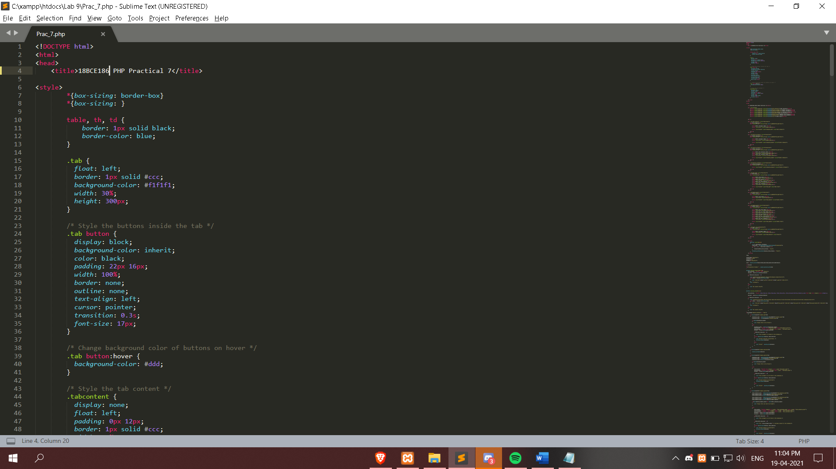

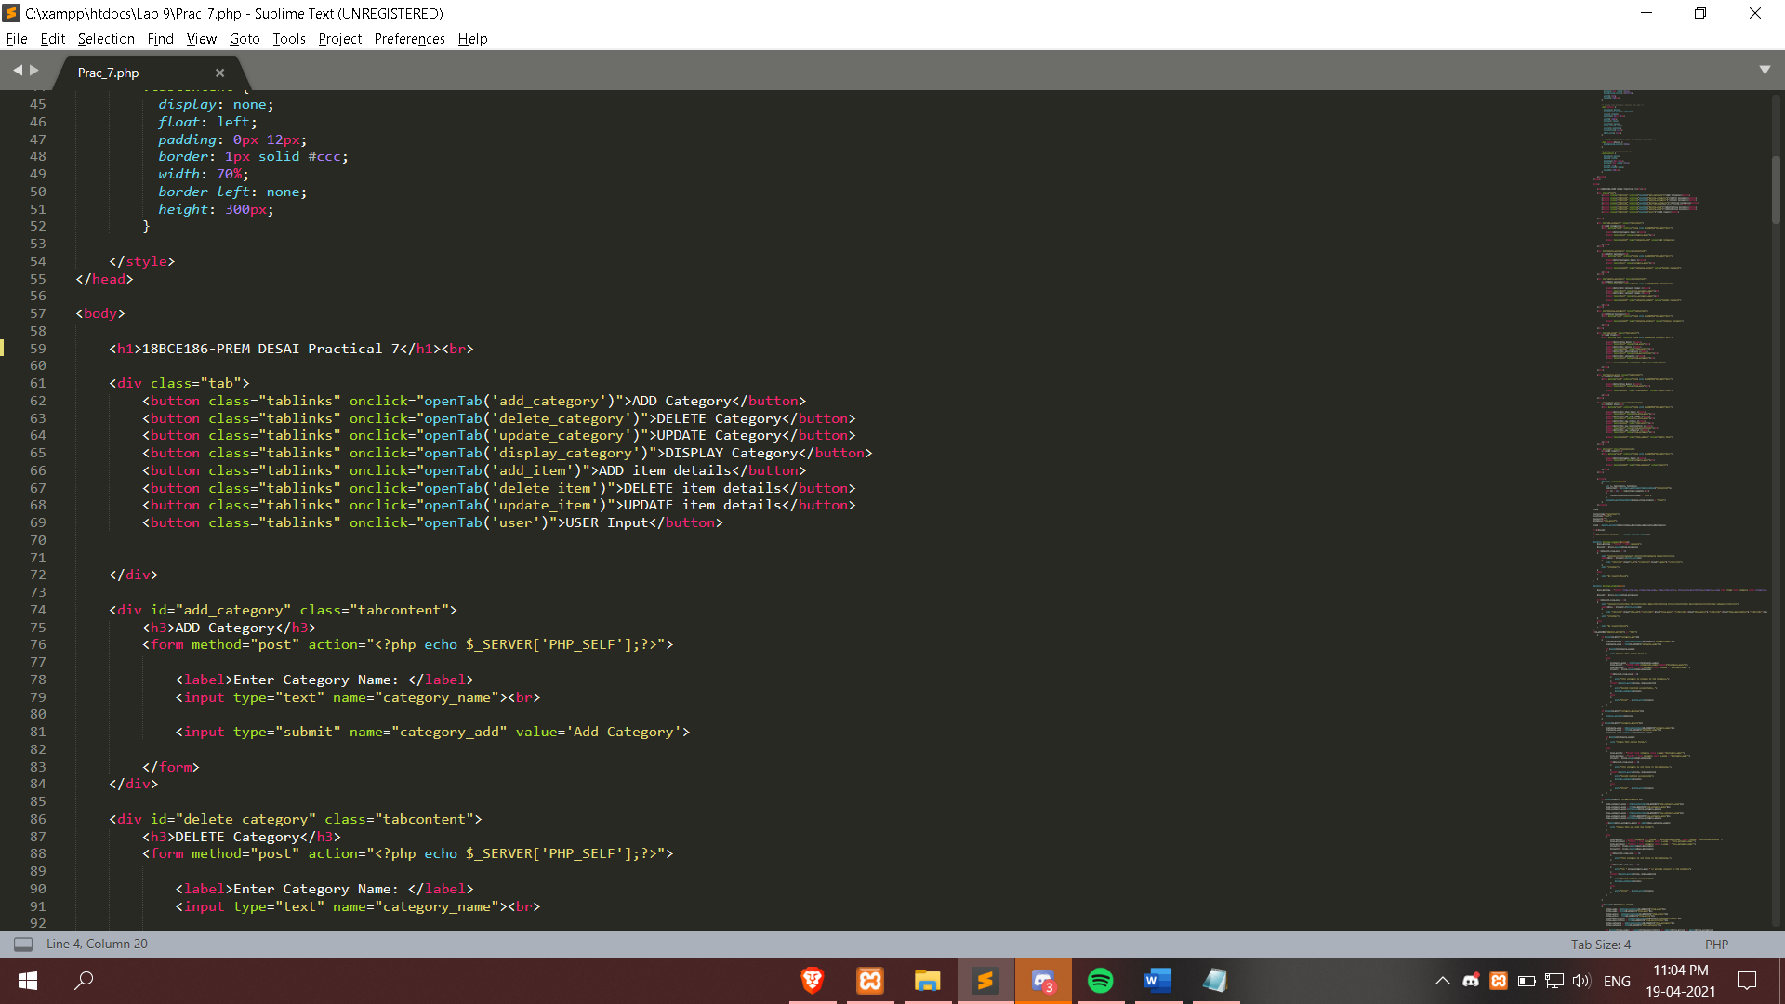

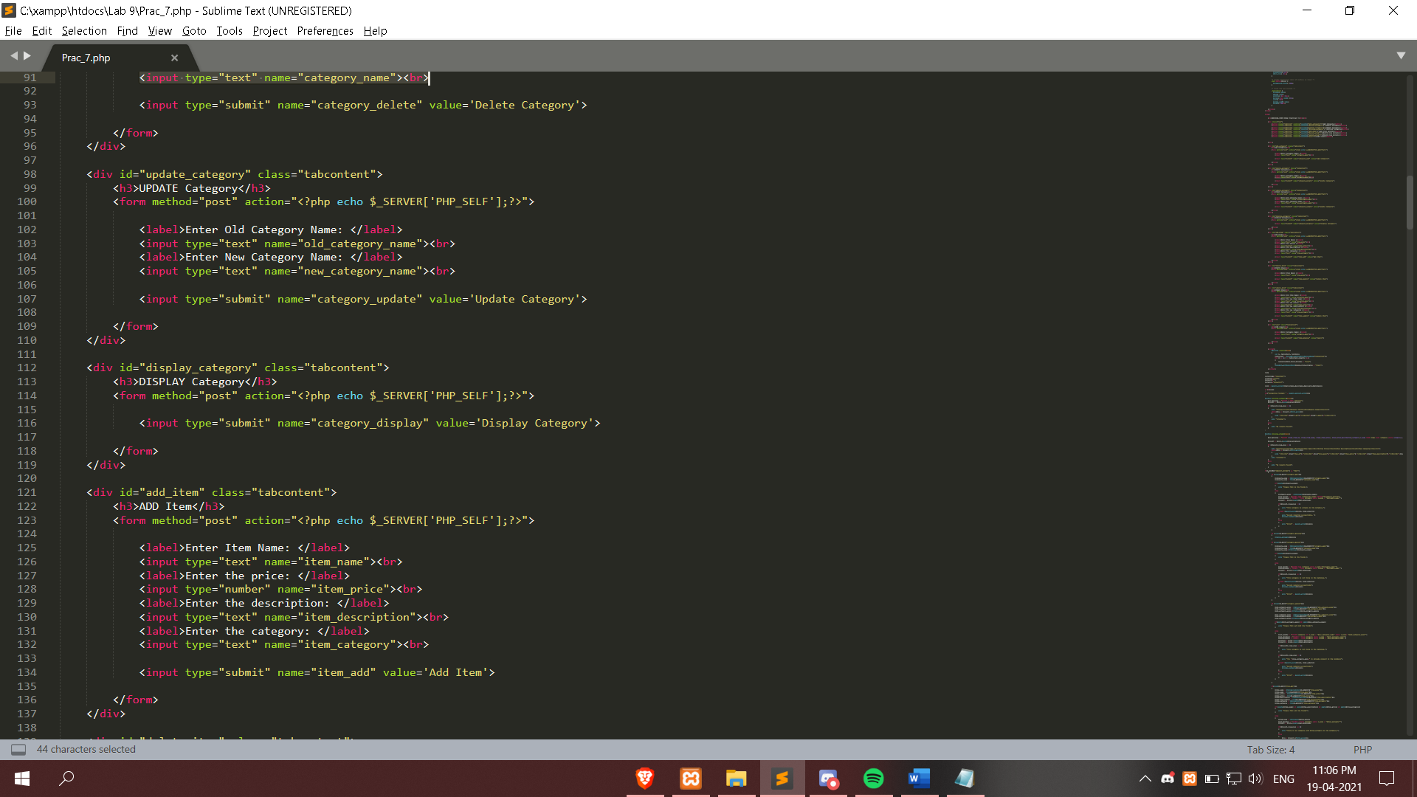

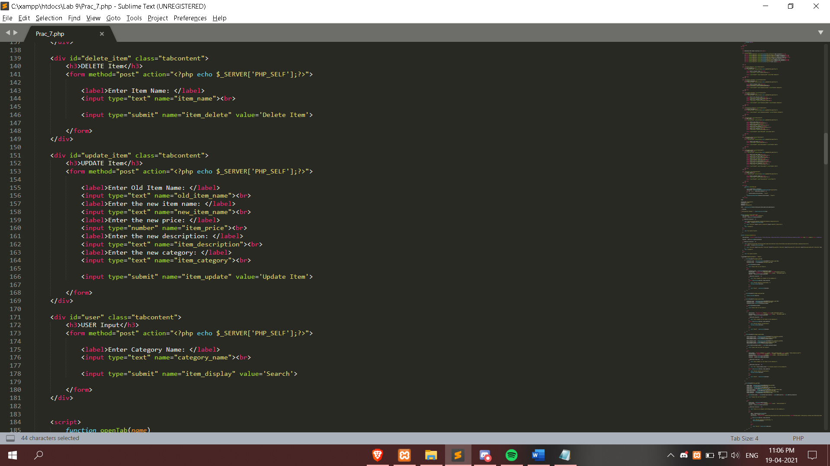

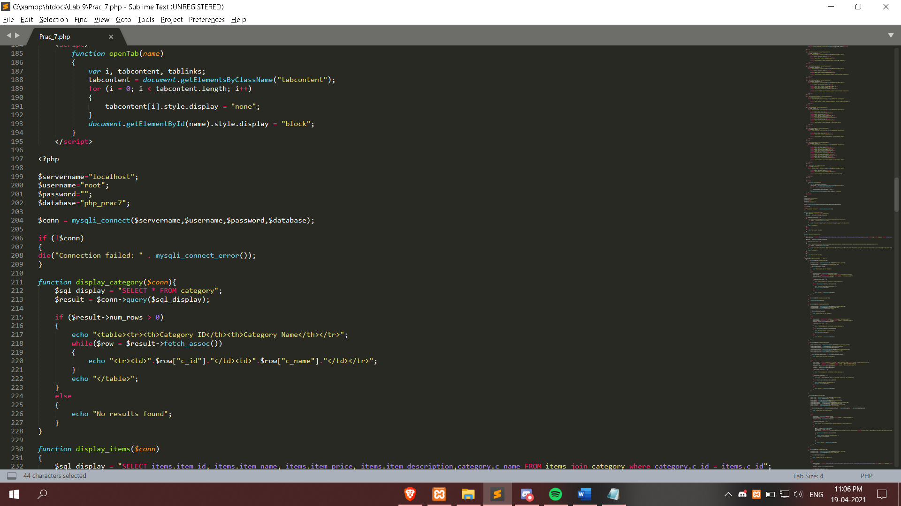

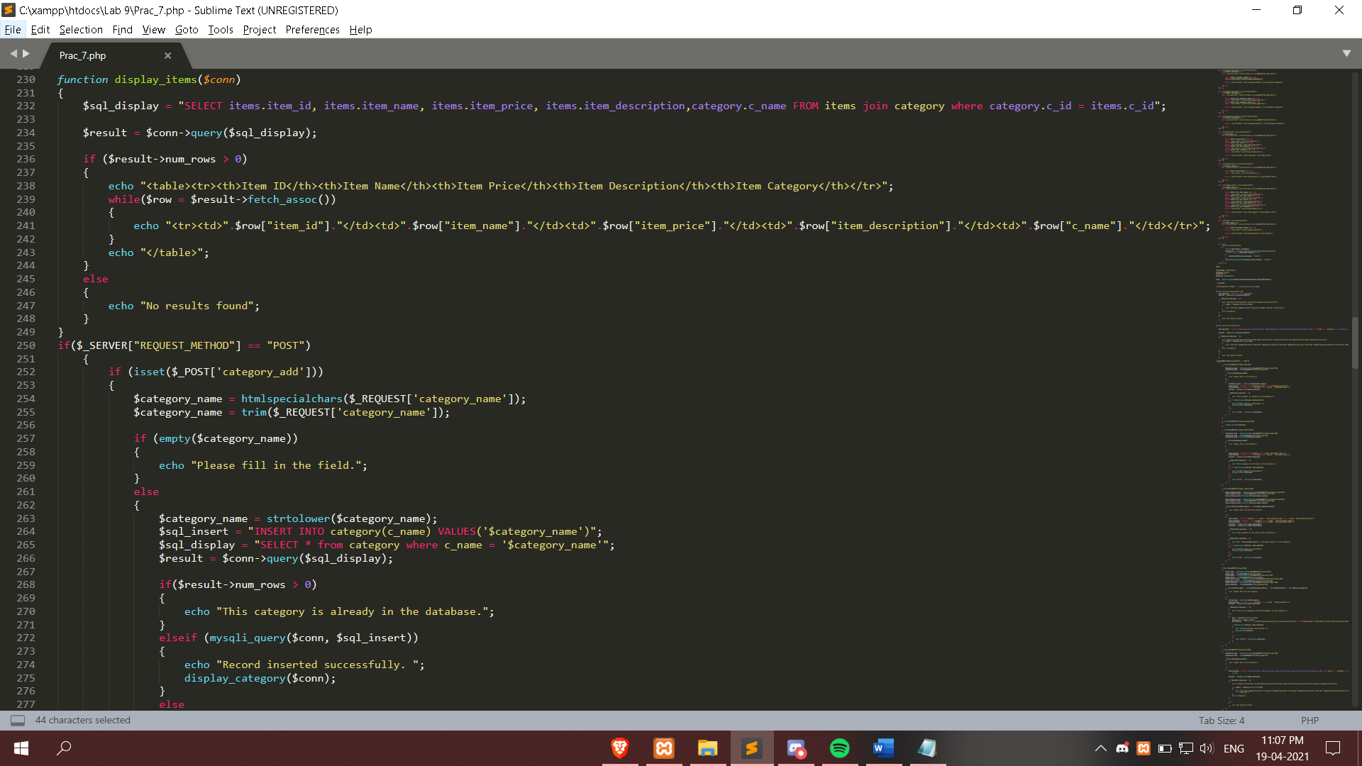

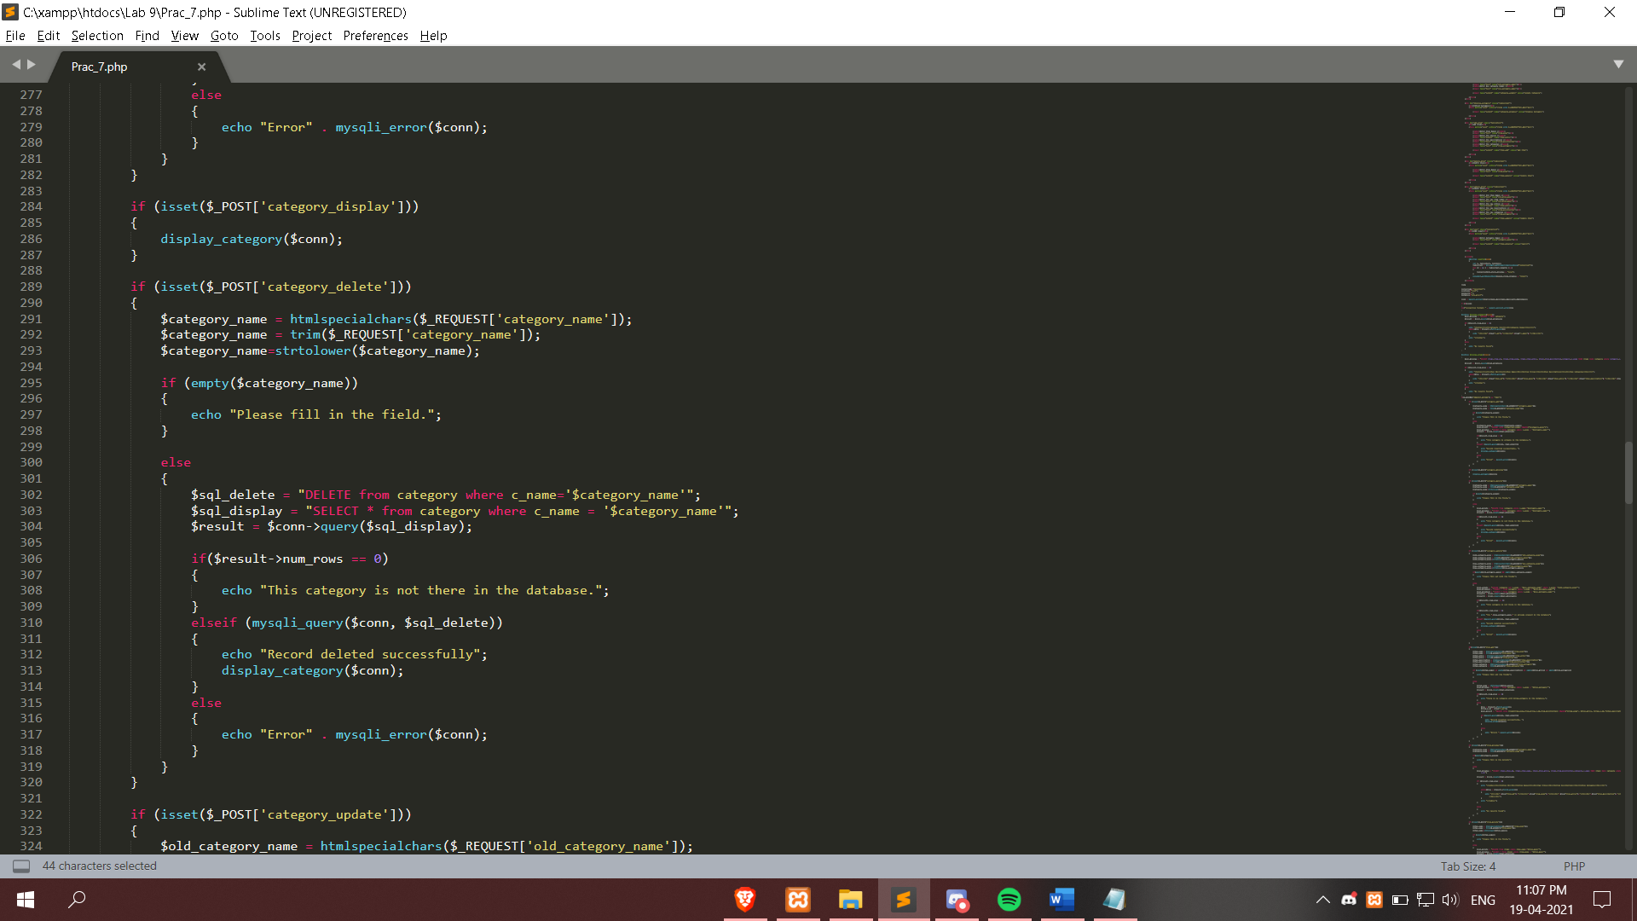

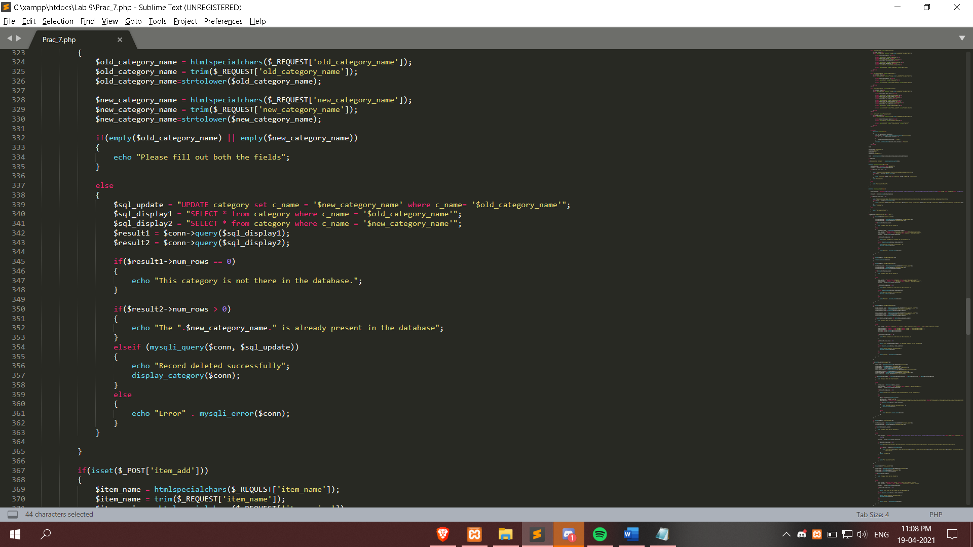

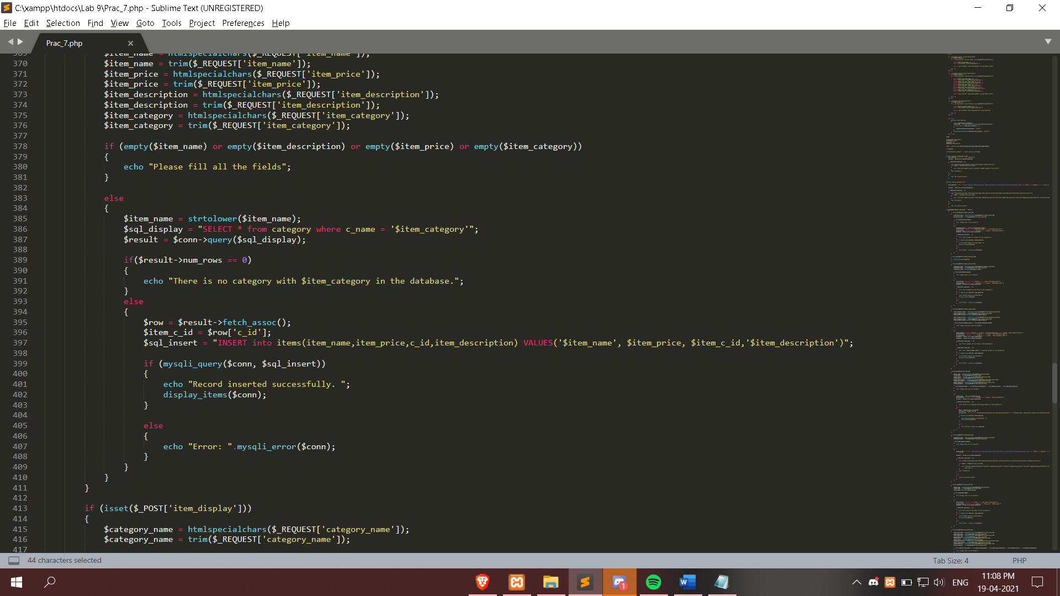

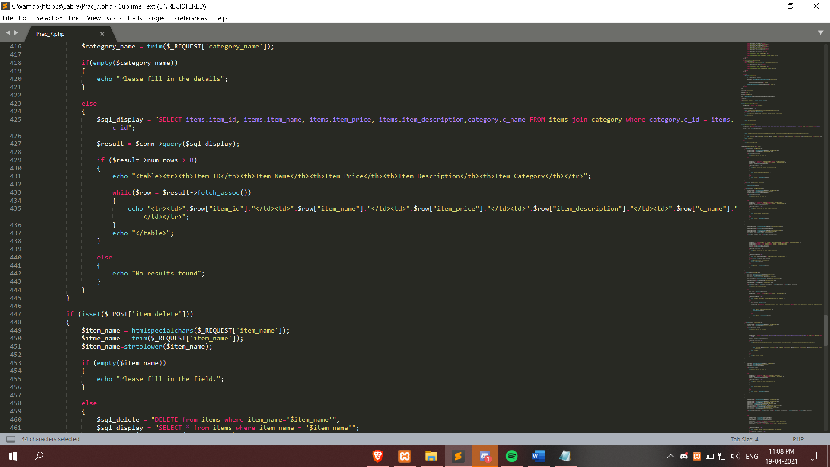

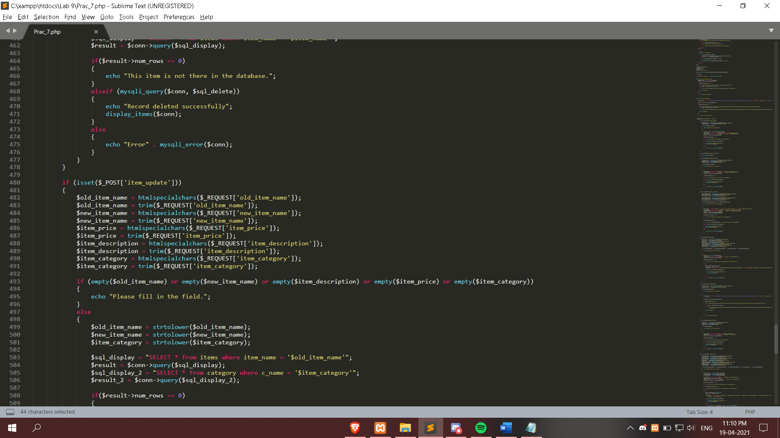

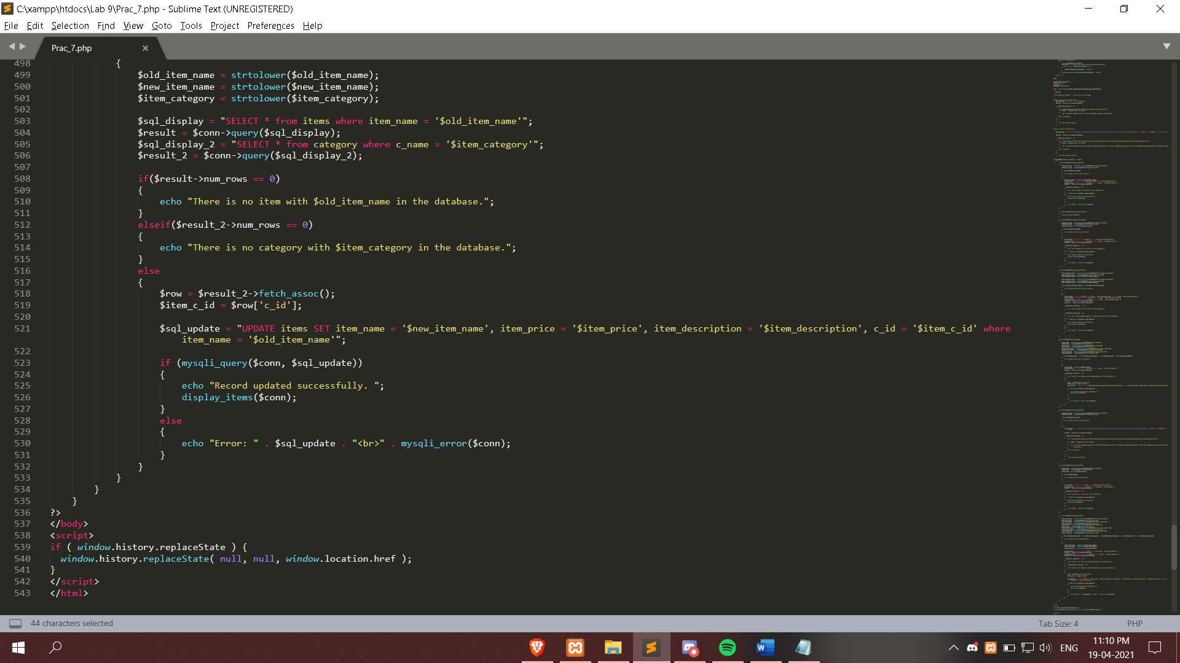

**Output :**

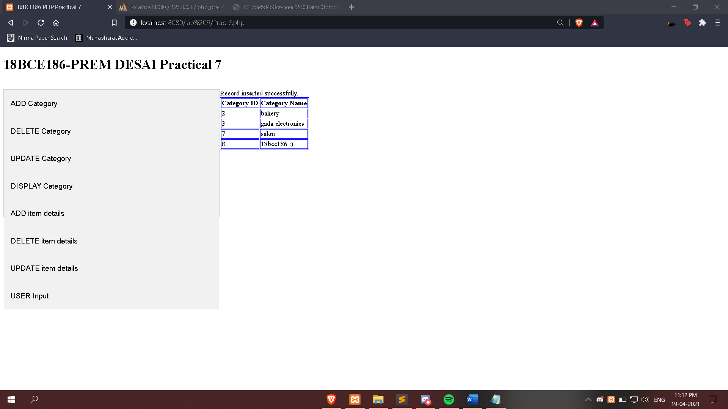

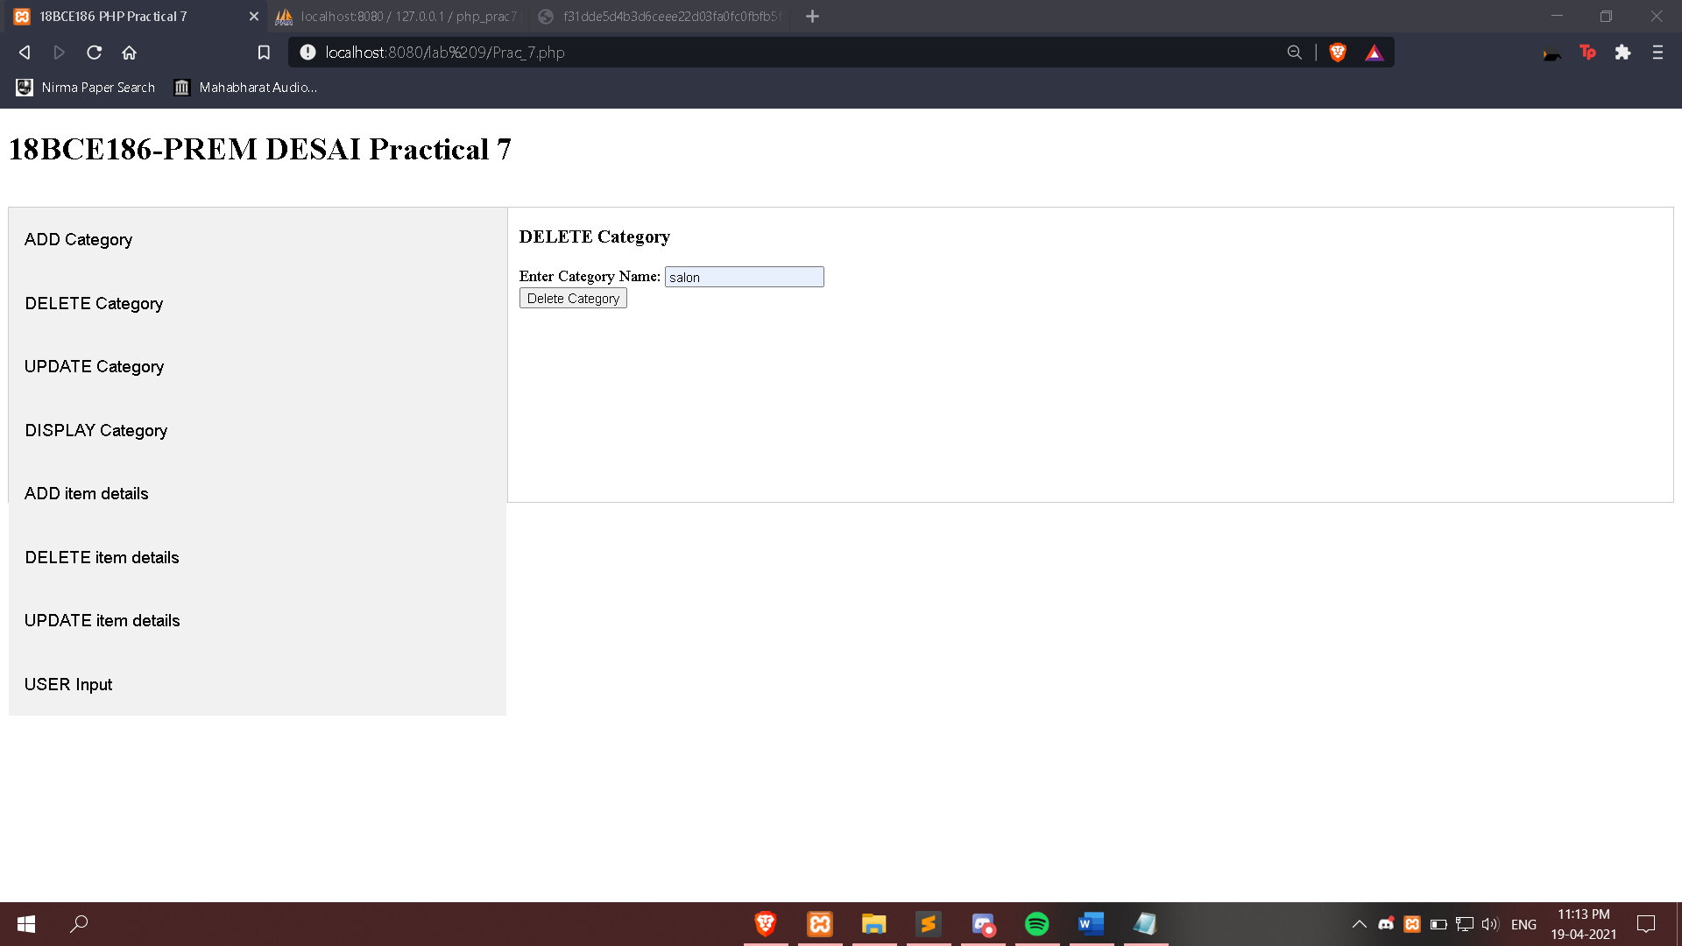

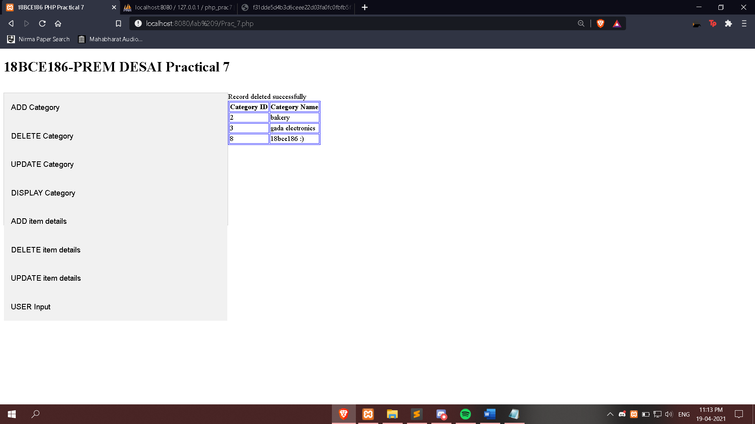

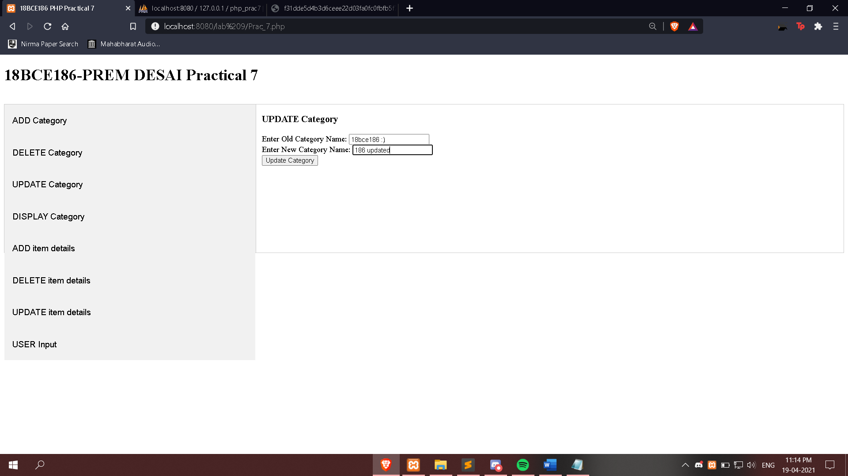

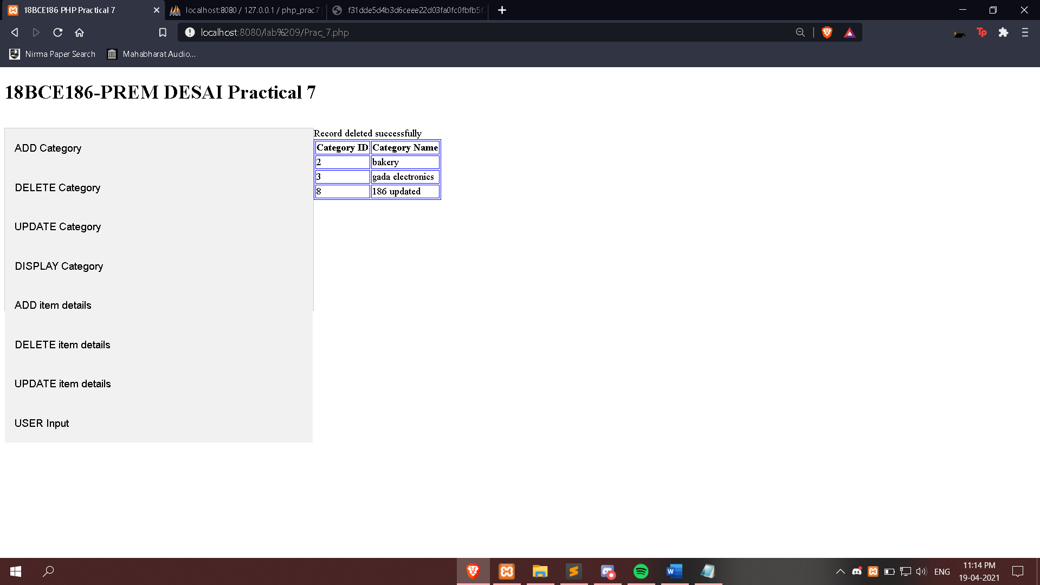

**Conclusion:**

**In this practical database configuration was performed and various functions were implemented.**